
GLOBAL ORGANIZATION OF PEOPLE
INDIAN ORIGIN (GOPIO), INC.

P.O. Box 1413, Stamford, CT 06904, USA
Tel: 203/329-8010, Fax: 203/322-2233
E-mail: gopio@optonline.net, Web: www.gopio.net

HE Matar Bin Humaid Al Tayer
UAE Minister of Labour and Social Affairs
Dubai
United Arab Emirates

Your Excellency,

The Global Organization of people of Indian Origin (GOPIO) wishes to submit to you the following MEMORANDUM:

The Global Organization of people of Indian Origin (GOPIO) is deeply concerned over the recent developments initiated by your Government concerning the cancellation of visa to the Indian labor working in the United Arab Emirates on the ground of age. This is against the agreed terms and principles of the employment standards and violation of employees’ rights.

The Global Organization of People of Indian Origin (GOPIO) is an international organization which is serving the interest of the 21 million Indian Diaspora; Non-Resident Indians (NRIs) and the Persons of Indian Origin (PIOs) all over the world. The GOPIO International (www.gopio.net) has National Chapters in several countries and cities and is the only international NRI organization, which was accredited by the United Nations as an NGO to participate in the World Conference Against Racism.

Your Excellency, India has strong economic and trade relations with your country and Indians have made important contributions to your country’s infrastructure, science and technology upgradation. The close ties between your country and India have been recently elevated to a higher level following a decision to institute a strategic dialogue and the signing of a defense cooperation agreement between the two countries. This long term broad strategic dialogue agreement shows the importance of bilateral relationship between the two countries. Out of roughly 3 million Indians working in the Gulf countries, 42 per cent live and work in your country. It is true that India has economically benefited a lot from these workers in terms of expatriate remittance, but at the same time, you will agree, that these workers have contributed to the economic prosperity and development of your country with their sweat and labor.

The GOPIO is concerned with your government’s recent decision and enforcement of new rules under which expatriate workers over the age of 60 years employed in the private companies are being fired and those companies who fail to cancel their visas and labor cards are being suspended. This new rule is affecting the lives of hundreds of workers who have been in your country as guest workers for last several years. Your country has offered them employment opportunities and they have done what was expected from them – give the best that any worker could give. This new development does not speak well for a country, which is host to thousands of Indian migrant workers. Blacklisting and suspending companies for their failure in canceling visas of elderly workers is a measure that might affect the bilateral relations in a long run at a time when trade and economic relations between the two countries are growing fast.

The UAE is a story of economic success worth emulating by other countries. Private sectors have played an important role in the wealth creation of the UAE. On the June 27th, this year while addressing prominent businessmen of your country, you stressed upon the importance of the private sectors and declared that your government will not impose any regulations without consulting the private sectors. The same private sector employers today are suffering because of the new rules targeting the Indian workers. The GOPIO firmly believes that Indian migrant workers even beyond the age of 60 have a lot to contribute to the economic miracle of the UAE. Indian workers are second to none when it comes to productivity and efficiency. Now when most developed countries have increased and the rest are on set to increase the retirement age from 60 to 65 years, it does not bid well for UAE to unilaterally enforce canceling the visa for those Indians above 60 years.

GOPIO would urge upon you to reconsider your decision and suspend/rescind the law and allow the Indian migrant workers to work beyond 60 years as per their capacity to perform work to the satisfaction of their employers. Realizing the importance of the Indian population in building of the UAE, GOPIO further believes that you will consider our request in right perspective and review your decision to allow these workers to work as long as they can contribute to your country’s prosperity.

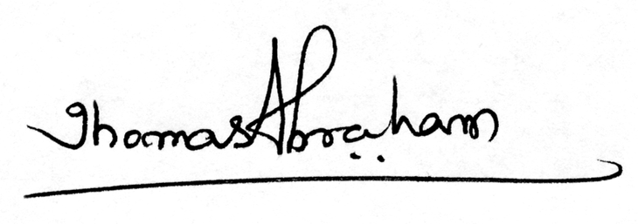Yours sincerely,
Dr. Thomas Abraham
President,
GOPIO International

